Pyramids
- Like the Sumerians at the same time, the Egyptians around 3000-2500 BC devoted a lot of energy to building big buildings.
- The Pharaohs, the rulers of Egypt, built the pyramids as tombs for themselves.
- The Pharaohs built all the pyramids during the Old Kingdom,

- The Step Pyramid is one of the first of these fancy tombs.
- Doesn't it look a lot like a ziggurat?

- Soon the Egyptians decided to fill in the steps of the pyramid. The first really pointed pyramids were built at Giza.
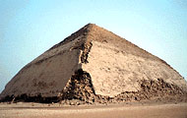 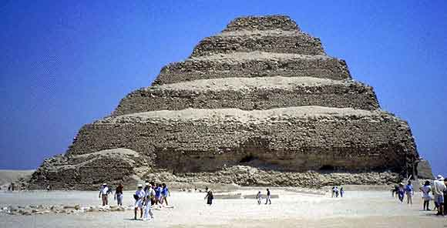 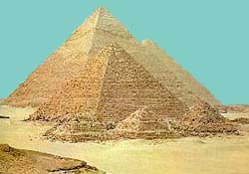
Bent Pyramid Step Pyramid Great Pyramids of Giza

- Most pyramids were accompanied by various smaller pyramids build to entomb the Pharaoh’s family, other members of royalty and the priestly class.
- Pyramids were built by farmers during the winter as a tax.
- The reason they built the pyramids next to the Nile River was so it would be easier to get the blocks to the pyramid. The stones could be bought nearer to the pyramid building site by boat.
- Guarding the pyramids is the Sphinx standing in front of all the pyramids of Giza. It has the body of a lion and the head of a pharaoh.
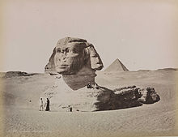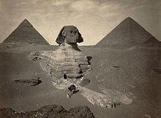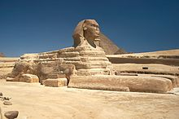
- Because of grave robbers, not a single mummy has been found inside the Pyramids so far.

- There are about 90 pyramids in Egypt.
Khufu’s Great Pyramid
- The Great Pyramid was built for the Pharaoh Khuf.
- It was built at Giza around 4500 B.C.
- Giza is west of the Nile, bordering the Sahara Desert.

- Khufu's Great Pyramid was the tallest building on earth for almost five thousand years, until the Eiffel Tower was built in 1889.

- This pyramid is believed to have been built over 20 years.
- It was built entirely of limestone.
- It contains around thirteen million stones!

- Each side is oriented towards one of the cardinal points of the compass: north, south, east and west.
- Its entrance faces north.

- King Khufu's burial chamber is located in the heart of the pyramid.
- The king's coffin is made of red granite, as are the interior walls of his chamber.
- 5 boat pits surround Khufu's Pyramid on the south and the east sides.
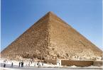
- The Sphinx stands guard in front of the pyramid. It has the body of a lion and the head of a pharaoh.

- Khufu’s Great Pyramid is the first of the Seven Wonders of the Ancient World. It is the only one still around today.
Great Pyramid For–Sale Assignment
Design a for-sale advertisement for the Great Pyramid of Giza. At the top create an image of the property. Under the drawing write a persuasive paragraph, advertising the property as being for sale. Use the information provided to write a detailed description of the pyramid. Grammar and spelling need to be correct. Property description must be written in paragraph form and not as a list.

