Epic of Gilgamesh Book Cover Assignment
Must include the following:
- Title: Epic of Gilgamesh
- Author: Sumerians
- Published in Mesopotamia
- First written epic
- Written in cuneiform
- Include a drawing
- Illustrated by (your name)
Your book cover will be graded on neatness, creativity, and inclusion of all information. Your book cover must be wrinkle-free and all information must be spelled correctly.
Use the following information to help you design your image.
Main characters of the book:
- King Gilgamesh – cruel/ great king
- Enkidu – wild, often horned man, Gilgamesh’s best friend, dies from wound
- Humbaba – fire-breathing demon who guards the forest, Gilgamesh cuts his head off
- Ishtar – Goddess of love and war, likes Gilgamesh but he does not like her
- Utnapishtim – Noah-like figure, survived the Great Flood
- Snake – eats the everlasting life plant that Gilgamesh found
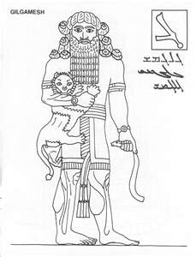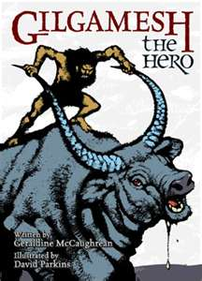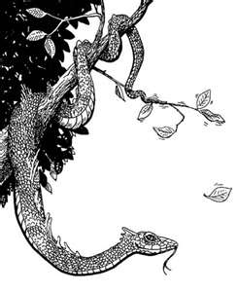
Hanging Gardens of Babylon Sale Listing
Design a for-sale advertisement for the Hanging Gardens of Babylon. At the top create an image of the property. Under the drawing write a paragraph, advertising the property as being for sale. Grammar and spelling need to be correct.
Include the following information in the property description:
- For sale by King Nebuchadnezzar.
- Built for the love of a homesick wife.
- Location: Babylon, near the Euphrates River
- Built in 600 B.C.
- Second oldest of the original Seven Wonders of the Ancient World.
- Image of property.
- Made from mud baked bricks.
- Includes pillars, vaults and terraces.
- Irrigation system with a chain pump, to bring up buckets of water.
- Stream of water runs down the middle.

Property description must be written in paragraph form and not as a list.
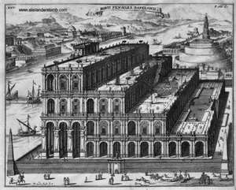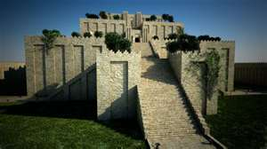
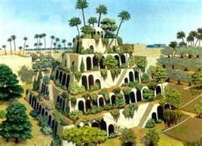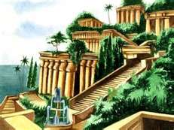
Grand Opening Flyer for the Royal Library of Ashurbanipal
Flyer must include most of the following information:
- Location: Nineveh, capital of the Assyrian Empire
- Opening in the 7th century BC.
- Builder: King Ashurbanipal
- First great library ever.
- The library inspired Alexander the Great to build his own library.
- Contains: 30,943 clay tablets written in cuneiform.
- Library includes:
1. Royal Inscriptions  2. Chronicles  3. Mythology  4. Religious texts  5. Royal Contracts  6. Royal letters | 7. Omens  8. Incantations  9. Hymns to various gods  10. Medicine  11. Astronomy | 12. Literature  - The Epic of Gilgamesh,  - Enûma Eliš, the creation story  - Myth of Adapa , the first man

- Drawing of Library
Use your imagination to design a building for the library. The building most likely would have had carved details and an arch doorway. Most likely it did not have windows.

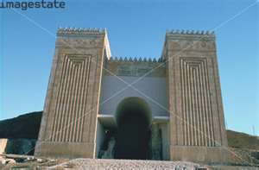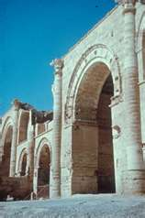
Architect Wanted to Build Great Tower in Babylon

Architect wanted:
King Nimrod wants a tower built to reach all the way to heaven. Architect must be able to oversee the construction and create an atmosphere of teamwork. Please submit all designs to King Nimrod.

