The Kings of Ancient Israel
King Saul of Ancient Israel
- In the year 884 BCE, 393 years after the Jewish people first entered the Land of Israel, Saul is anointed as the first king by the prophet Samuel in accordance with the wishes of the people.
- Saul was head and shoulders above everyone physically.
- Saul was head and shoulders above everyone morally and ethically.
- His one weakness ― his sense of humility interferes with his duty as king.
- When the Ammonites invade, Saul finally rises to the occasion and accepts kingship. He went on to lead the Jewish people in a series of victories against her enemies and thus establishes his authority as king and solidifies his leadership.
- Saul's reign lasts from 884 to 882 BCE.
- Saul later became jealous of David because of David’s battle field victories.
- King Saul died at the Battle of Gilboa.
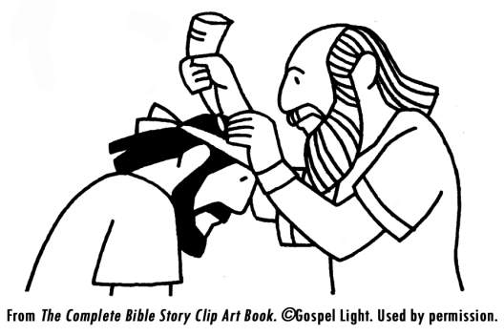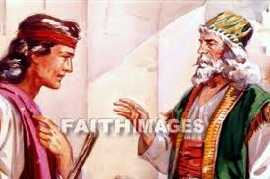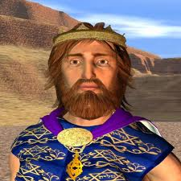
King David of Ancient Israel
- Fought Goliath with a sling shot.  - Second King of Israel  - Warrior  - Poet  - Musician  - Was king from 1010 to 970 B. C. | - Ruled for 40 years.  - He united the people of Israel.  - He led them to victory in many battles.  - He built the city of Jerusalem as his capital.  - He paved the way for his son, Solomon, to build the Holy Temple.  - He came from the town of Bethlehem were he was a shepherd.
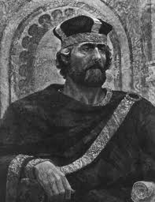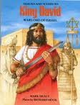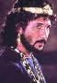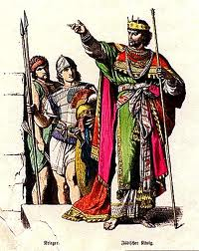
King Solomon of Ancient Israel
- King David’s son  - Ruled from 970 to 928 B.C.  - He was king for 40 years.  - He was a writer.  - He composed 3,000 proverbs and 1,005 songs.  - He wrote the Song of Songs, the Book of Proverbs and Ecclesiastes. | - He amassed great wealth.  - He had foreign alliances with Egypt and Phoenicia.  - He built numerous cities.  - He constructed copper smelting furnaces.  - He built the first holy Temple in Jerusalem.  - He was buried in the City of David.
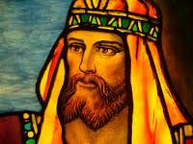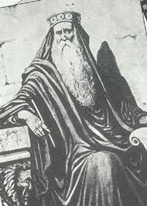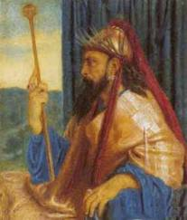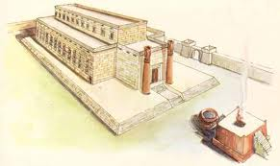
King Herod of Ancient Israel
- Herod was born in 75 B.C.  - He ruled from 37 to 4 B.C.  - He was disliked by the Jews because they were all too aware that his true loyalty was to the Romans who made him king.  - He had many buildings built during his reign.  - In 20 B.C. he began the reconstruction of the Temple of Jerusalem. It was finished in 10 B.C.  - Herod is believed to have died at his Winter Palace in Jericho around 4 B.C.  - He is believed to have killed some of his own children from time to time, and at least one of his numerous wives. | - He is reported to be the one who tried to have the infant Jesus killed.  - With reports of the birth of the "king of the Jews" he had all the male children in Bethlehem and in that region who were two years old or under killed. (some say he did not have the power to do this because the Romans were really in charge).  - Not very long (maybe a year) after Joseph and Mary fled with Jesus into Egypt, they heard that Herod was dead and they returned to Israel.  - Some records say Herod was a great king and was made to look bad by the Israelites.
