Ancient India – 6th Grade
A scholar could study which epic to learn about early Indian culture?  A. The Aeneid  B. Gilgamesh  C. Mahabharata  D. The Odyssey | 2. What early invention from India had a great impact on the study of mathematics and science?  A. The telescope  B. The symbol “0”  C. The printing press  D. Hieroglyphics | 3. In ancient India’s caste system, which social class was above all others?  A. Brahmins  B. Kshatriyas  C. Vaisyas  D. Sudras
4. What belief or practice do Hinduism and Buddhism have in common?  A. A person’s rank based on birth  B. Meditation  C. Worship of many gods  D. Elaborate rituals | 5. Traveling to a holy place to worship is called a _______.  A. Exile  B. Reincarnation  C. Stupa  D. Pilgrimage | 6. Siddhartha Gautama, who became the Buddha, began life as the son of a _____.  A. peasant  B. ruler  C. priest  D. cobbler
7. Hindus believe ______ is the universal spirit.  A. Ganesh  B. Buddha  C. Shiva  D. Brahman | 8. ______ is a collection of sacred Hindu verses, hymns, prayers and teachings.  A. Vedas  B. Karma  C. Caste  D. Nirvana | 9. Which characteristic below is true of Buddhism, but not of Hinduism?  A. Belief in reincarnation  B. Originated in India  C. Emphasis on fasting  D. A historical founder
?  Path to Enlightenment  Siddhartha  Four NobleTruths  Which religion completes the diagram above?  A. Buddhism  B. Islam  C. Hinduism  D. Taoism | 11. Why was the settlement of India’s early civilization near the Indus River important to economic growth?  A. Because people had a plentiful supply of food, they could spend time making and doing other things.  B. People traded their extra food and goods with other people.  C. As wealth grew from trade, people built larger cities.  D. All of the above | 12. ?  Brahman  Karma  Dharma  Ganges River  Which religion completes the diagram above?  A. Buddhism  B. Islam  C. Hinduism  D. Confucianism
13. In Buddhism, which of the following would be described as “freedom from ignorance, prejudice, and superstition?”  A. Karma  B. Stupa  C. Reincarnation  D. Enlightenment | 14.  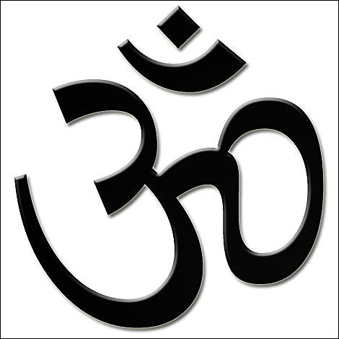  A. This is the sacred Buddhism symbol.  B. This is the sacred Islam symbol.  C. This is the sacred Judaism symbol.  D. This is the sacred Hinduism symbol. | 15. If you helped an old lady carry her groceries to her car and later that day you found $5.00, some might say you have good ________.  A. Dharma  B. Karma  C. Stupa  D. Vedas
16. Buddhist call this symbol the ___.  A. Wheel of Life  B. Reincarnation  C. Eightfold Path  D. Aum | 17. Who believed “Life is filled with suffering”?  A. Ganesh  B. Buddha  C. Shiva  D. Sargon | 18. The cycle of birth, life, death & rebirth is ________.  A. Nirvana  B. Reincarnation  C. Hinduism  D. Karma

