Ancient India Epics
Epic – A long narrative poem, usually about heroic deeds.
Mahabharata
- The Mahabharata is a great epic from India.
- The longest epic in the world.
- 100,000 verses divided into 18 books.
- Original language: Sanskrit
- Written between 400 BC and 400 AD.
- Best know section is the Bhagavad Gita (The Song of the Lord).
- Epic describes a great war for control of an Indian kingdom.
- Its main subject is a bloody feud between two branches of a ruling family; the Pandavas and the Kauravas.
- Their conflict leads to an 18-day battle and the deaths of nearly all those involved in the war, except the winners, the five Pandava brothers—and a handful of others.
- Krishna – (deity with blue skin, teacher of the world) acts as a chariot driver.
- Before a great battle Krishna tells the warriors about life going on after death.
- The Mahabharata contain many Hindu beliefs.
- The poem focuses on the Hindu concept of dharma, or sacred duty.
- Besides being a heroic tale, the Mahabharata discusses ethics, law, philosophy, history, geography, genealogy, and religion.
- It also features a number of legends, moral stories, and local tales all woven into an elaborate narrative.
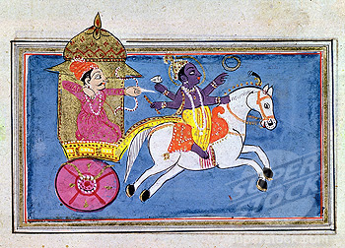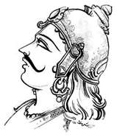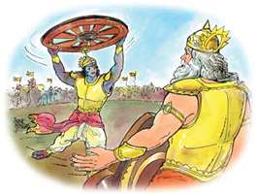
"That which is found in these pages may be found elsewhere,
but what is not in these pages exists nowhere."
- Mahabharata
Mahabharata
The five sons of Pandu, the Pandavas, are the heroes of the story. The oldest is Yudhishthira, the King. Next is Bhima, an enormously strong fighter with equally enormous appetites. Third is Arjuna, the greatest of the warriors, and the companion of Krishna. The last two are twins, Nakula and Sahadeva.
The enemies of the Pandavas are the Kauravas, who are the sons of Pandu's brother, Dhritarashtra. Although Dhritarashtra is still alive, he cannot manage to restrain his son Duryodhana, who bitterly resents the achievements of his cousins, the Pandavas. Duryodhana arranges for his maternal uncle to challenge Yudhishthira to a game of dice, and Yudhishthira gambles everything away, even himself. The Pandavas have to go into exile, but when they return they engage the Kauravas in battle. Krishna fights on the side of the Pandavas, and serves as Arjuna's charioteer. The famous "Song of the Lord," or Bhagavad-Gita, is actually a book within the Mahabharata, as the battle of Kurukshetra begins. When Arjuna faces his cousins on the field of battle, he despairs and sinks down, unable to fight. The Bhagavad-Gita contains the words that Krishna spoke to Arjuna at that moment.
The Pandavas do win the battle. Duryodhana is killed, and the Kaurava armies are wiped out. But it is hardly a happy ending. Yudhishthira becomes king, but the world is forever changed by the battle's violence.
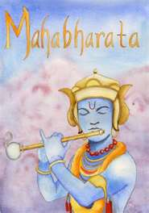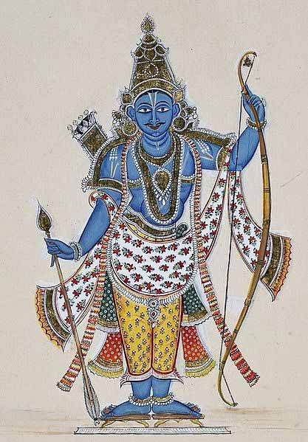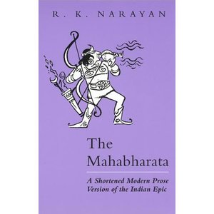
Assignment: Book Cover Design
Select one epic from India (Mahabharata or Ramayana). Design a book cover for the epic. Be sure to include the following.
- Written in Sanskrit
- Date written
- Published in Ancient India
- Illustration
- Illustrated by: Your name
- 2 Facts
Ramayana, an Epic from India
Title: The Ramayana ("Journey of Rama")

- Author: The poet Valmiki first wrote Ramayana around 300 BC and it has been added to over the years.
- Setting: 1500 BCE, India
- Length: Long - about the length of the entire Christian Bible. Contains 24,000 couplets in seven books.
- Original language: Sanskrit

What it's about?
A virtuous king named Rama is banished to the forest, where he has many adventures, then he rescues his wife Sita from the evil king of Sri Lanka with the help of his friends.
Who's in it?
Rama - 7th incarnation of Vishnu and virtuous king of Ayodhya
Sita - incarnation of Lakshmi
Ravana - evil king of Sri Lanka
Hanuman - monkey-general and devotee of Rama
Sugriva - king of the monkeys
Lakshman - Rama's devoted half-brother

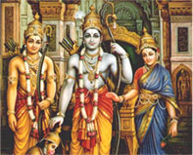
Long time back, in the kingdom of Ayodhya, there lived a noble king known as Dashratha. He had four sons. The oldest one was called Rama and was known for his idealist values and outlook. He is considered to be the seventh incarnation of Lord Vishnu. The king decided to crown Rama, as he was the rightful heir to the throne.
But the king's second wife, Kaikeyi grew jealous and she wanted her son to be the king. She reminded the king of a promise he gave her long ago and made him announce that her son would be the king. Rama was exiled for a period of 14 years. Being the obedient son and an idealist, Rama obeyed his father and bid farewell to the kingdom and its riches.
Rama set out with Sita (his wife) and Lakshmana (brother) on his 14 year long exile in the forests of India. One day, a Demoness saw Rama and was mesmerized by his charming personality. She tried to seduce him but he ignored her completely. She then tries to seduce Lakshmana, but enraged, he cuts off her nose. Thoroughly insulted, she goes back to her brother Ravana, the Demon king of Lanka and complains about what happened. Ravana seeks revenge by abducting Sita and taking her to his palace. Determined and confident, Rama sets out to find her. He is helped by a group of monkeys who put in their best efforts to get Sita back from Lanka. Ravana is spoken of as a powerful demon, who was blessed by many Gods. His only flaw was vanity.
A battle takes place between the monkey army of Rama and the demon army of Ravana. In the end, Rama emerged victorious and was united with Sita. By this time, their exile had ended and they returned back to their kingdom victorious. Rama was crowned the king and he proved himself to be a devoted ruler. The moral of this epic is good always triumphs over evil. No matter what happens, one must never accept anything wrong and never deter from his path of duties of life.
