Geography
Locations | Landscape | Bodies of Water
- Macedonia  - Greece  - Peloponnesus  - Asia Minor  - Crete | - Mt. Olympus*  - Balkan Peninsula  Greece is coved with mountains and little land to farm. | - Aegean Sea*  - Gulf of Corinth  - Ionian Sea  - Mediterranean Sea*  - Sea of Crete  - Sea of Marmara

Important Cities
Important Cities
- Delphi  - Sparta  - Athens | - Troy  - Knossos  - Olympia

Important People
Leaders | Writers | Philosopher | Math / Science
- Agamemnon  - Alexander the Great  - Cyrus the Great  - Darius  - Pericles | - Aesop  - Homer | - Aristotle  - Plato  - Socrates | - Archimedes  - Euclid  - Pythagoras

Government
Types of Government
Tyrant | Oligarchy | Direct Democracy | Representative Democracy
A person who takes power by force and rules with total authority. | A few people ruled the many. | Citizens rule directly and not through representatives. | Citizens choose a smaller group to govern on their behalf.

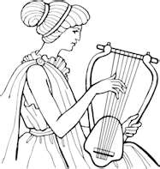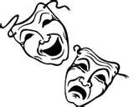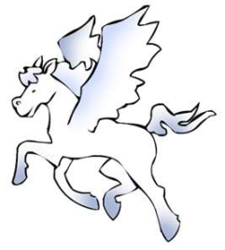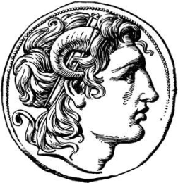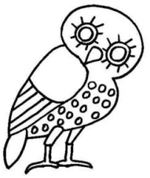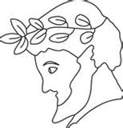
Social Class
Social Class System
- Aristocrats- wealthy men who owned property or military men
- Farmers were the middle class.
- Thetas- Craftsmen and men who did manual labor
- Slaves – Helots - ancient Spartan slaves
Freeman – Male citizens of Athens
Women had no rights and were rarely seen outside the home.

Trade & Economy
Traded | Traded with | Traded for
- Grapes  - Wine  - Olives  - Wool  - Pottery  - Wheat  - Barley | - Egypt  - Mesopotamia | - Meat  - Lumber  - Vegetables

Religion Polytheism – Believed in many deities and fate.
12 Major Olympian Deities
Gods | Goddesses
Zeus – king & weather | Hera – queen, women & marriage
Poseidon – sea, earthquakes & horses | Demeter – grain & growing
Apollo – sun, truth, music, healing, dance & poetry | Hestia* – home & hearth
Hermes – travel, business & sport | Aphrodite – love & beauty
Ares - war | Athena – war, wisdom & art
Hephaestus – fire, volcanoes, blacksmith, & craft-workers | Artemis – moon & wild animals
Dionysus* – food & drink

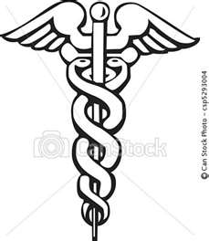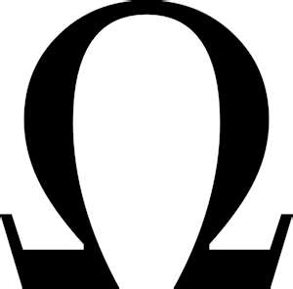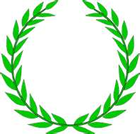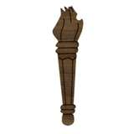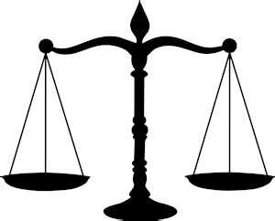
Writing System – based on the Phoenician alphabet.
Literature
Myths | Epics | Fables | Histories | Poetry | Dramas
Gods & Heroes  - Expressed religious believes  - Explained nature | Homer  - Iliad  - Odyssey | Aesop  Tortoise & the Hare  Taught values and morals. | - Herodotus  - Thucydides  Wrote the first histories of western civilization. | Taught Greek values and morals. | - Comedies  - Tragedies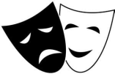

Buildings
Parthenon – Temple build for the goddess Athena on top of Athens’s acropolis.
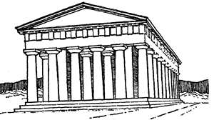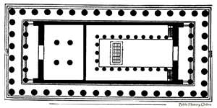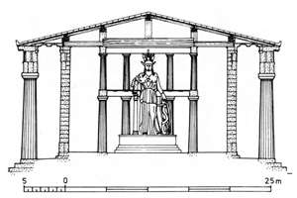
Accomplishments
- Democracy – (Athens) still used by the U.S. government.
- Architecture - ideas & style copied by others (columns) – Lincoln Memorial.
- Art – ideas of beauty and harmony copied.
- Theater and drama – we now have plays, movies and TV.
- Archimedes - solid geometry, Pi, catapult, & lever systems.
- Euclid – plain geometry.
- Aristarchus – Earth circled the sun.
- Eratosthenes – Earth is round, measured the distance around the earth.
- Pythagoras – set principles of geometry.

Vocabulary
Peninsula  Colony  Polis  Agora  Oligarchy  Direct Democracy  Representative Democracy | Tyrant  Zoroastrianism  Philosopher  Plane geometry  Solid Geometry  Astronomer  Fable | Drama  Tragedy  Comedy  Legacy  Myth  Oracle  Epic | Philosopher  Sophist  Socratic method  Hellenistic Era  Epicureanism  Helot  Satrap

