The Lighthouse was built on the Island of Pharos in the harbor of Alexandria, Egypt. It was started around 290 BCE and completed 20 years later. It was the first lighthouse of the world. The lighthouse helped ships find their way safely into harbor. It was also a tourist attraction. Except for the Great Pyramid, it was the tallest man-made structure in the world.
Visitors could buy food at the observation platform on the first level. Anyone who wished could climb nearly to the top. There were not many places in the ancient world that visitors could climb a man-made structure, 300 feet up, to view the sea.
This lighthouse was designed differently than modern lighthouses. It was more like a 20th century sky scraper. There were three stages which were piled one on top of each other. The lowest level was about 200 feet square and was shaped like a huge box. The blocks on which the lighthouse was built were marble.
There was a staircase in the lighthouse that led the keepers to the beacon chamber. In there, was a curved mirror. It was used to project a fire's light into a beam. Ships could detect the beam from the tower at night or the smoke from it could be seen during the day from up to 100 miles away.
The Lighthouse stood for over 1500 years. Scientists believe an earthquake topped the Lighthouse during the 1300's.
Divers today search for remains at the bottom of the Mediterranean Sea.
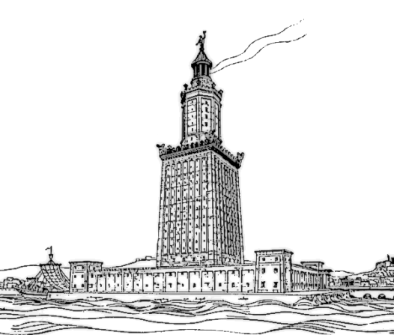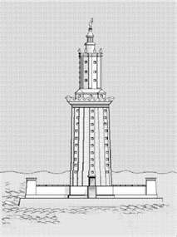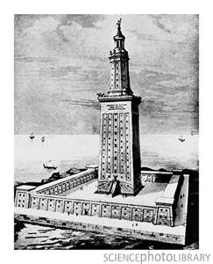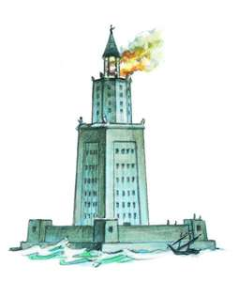
Assignment
Design a for-sale advertisement for the Lighthouse of Alexandria. At the top create an image of the property. Under the drawing write a persuasive paragraph, advertising the property as being for sale. Use the information provided to write a detailed description of the lighthouse. Grammar and spelling need to be correct. Property description must be written in paragraph form and not as a list.

