Front Cover of Ancient Greece Geography Booklet
Ancient  Greece  Geography  Picture Here | Vocabulary  Define the following:  - Acropolis  - Agora  - City-state  - Colony  - Democracy  - Oligarchy  - Parthenon  - Peninsula
Inside of Booklet
Landscape of Greece  Cities  - Delphi  - Sparta  - Athens  - Troy  - Knossos  - Olympia  Locations  - Macedonia  - Balkan Peninsula  - Greece  - Peloponnesus  - Asia Minor  - Crete  Mountains  - Mt. Olympus  Bodies of Water  - Ionian Sea  - Mediterranean Sea  - Gulf of Corinth  - Sea of Crete  - Aegean Sea  - Sea of Marmara | Ancient Greece  Map of Greece  In this section draw a map of Greece. Label all of the features listed on the left.  Use the following pages to complete your map.  117, 121, 125  Decorative Frame  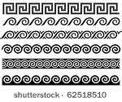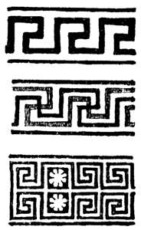 | Aegean Sea  - Sailors  - Fishers  - Traders  Trade  - Who did the Greeks trade with?  - What did the Greeks trade?  - What did the Greeks trade for?
