Egyptian Book of the Dead Cover Assignment
Include the following information in your design:
- Title: Book of the Dead
- Author: Ani, the Royal Scribe
- Published in Egypt
- Written in hieroglyphs
- Written on papyrus
- Illustrated by (your name)
- Drawings related to the book.
Your book cover will be graded on neatness, creativity, and inclusion of all information. Your book cover must be wrinkle-free and all information must be spelled correctly.
Use the following images and information to help you design your cover.
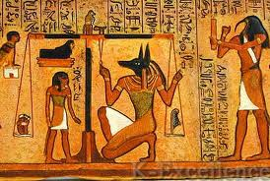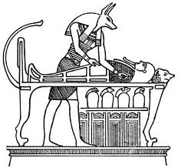
- Osiris: God of the Underworld, always wore a mummy-dress, sat in judgment.
- Anubis: God of the Dead & Embalming had a jackal head and lead the dead.
- Thoth: God of Wisdom & Writing had an ibis-stork head and carried writing tools; he recorded the results on the Balance of Truth.
- Ammut: Egyptian demoness, known as the 'Eater of Hearts' and 'The Devourer'. She had the head of a crocodile, the body of a leopard and the backside of a hippopotamus.
Egyptian Book of the Dead
- An ancient survival guidebook which contained magical spells and instructions for safe passage through the dangers of the Underworld to the Afterlife.
- A papyrus scroll containing sections and spells from the Book of the Dead was buried with the Ancient Egyptians to help them leave their tombs and through their dangerous journey and the obstacles they would face in the underworld.
- The Book of the Dead was recorded by a royal Scribe called Ani. The Papyrus of Ani was originally 78 feet long and was divided into chapters.
Contents of the Egyptian Book of the Dead:
- The Egyptian Book of the Dead was a sacred document studied by Egyptian elite such as well-educated Egyptians, Royalty and Priests.
- It provided them with an understanding of their religion and gave them a great advantage in the understanding of the Underworld and the Afterlife and the trials that they would face.
- The Egyptian Book of the Dead contained nearly 200 different spells.
- Each spell was designed to help with the tests and trials that would be met in the Underworld.
- The correct spells would need to be recited to pass each test.
- After completing the trials a soul was led to the Hall of Two Truths where their actions in their mortal lives would be examined.
Ancient Egyptians Believed:
- Life and Death were seen as stages of progress to a better life in the next world.
- Mummification - The Egyptians believed that preserving the body in death was important to keep their soul alive - without a physical body the soul had no place to dwell and became restless forever.
- The Underworld, called Duat, was a land of great dangers, which every Egyptian would have to pass through after death.
- The dangers of the Underworld included a variety of obstacles including fearful beasts, traps, demons and a long series of tests.
- Hall of the Two Truths - Anubis, the God of the Dead and Embalming, would lead the dead through the dangers of the Underworld to the Hall of Two Truths and the ceremony of justification before Osiris and 42 judge deities.
- A set of scales were used to weigh the dead person’s heart against the feather of truth and then their fate would be decided - either entrance into the perfect afterlife or sent to the Devourer of the Dead.
- The Afterlife - A perfect existence in an ideal version of Egypt. Ancient Egyptians provided for their afterlives according to their earthly means. The Afterlife was referred to as the Field of Rushes or Field of Offerings.
