Great Pharaohs of Egypt
Pharaohs – Egyptian kings
King Narmer or Menes
- Old Kingdom
- First Egyptian pharaoh, from the first dynasty
- United lower and upper Egypt in 3100 BC
- Was called "the King of Both Lands and Bearer of Both Crowns".
- First king of the two lands to wear the White Crown of Upper Egypt (looks like a bowling pin), and the Red Crown of Lower Egypt.
- His rule marked the beginning of written history and the era of dynasties.
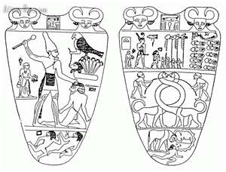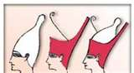

Hatshepsut
- New Kingdom  - Reigned 1473-1458 B.C.  - Hatshepsut; means Foremost of Noble Ladies  - When her husband dies she declared herself pharaoh.  - Was the fifth pharaoh of the eighteenth dynasty of Ancient Egypt. | - She often wore men’s clothing to prove she could handle the job.  - Avoided military conquests.  - Focused on economy.  - Traded with African and Asia.  - Rebuilt great temples.  - 21 year reign was peaceful.
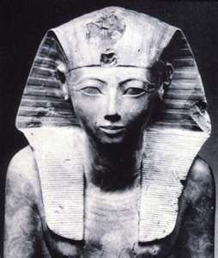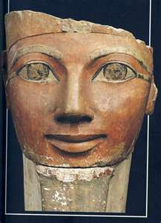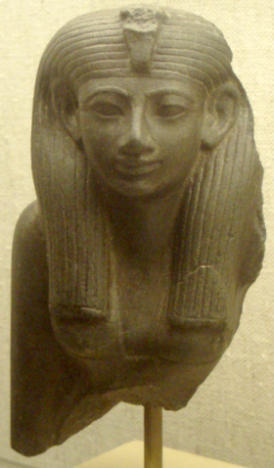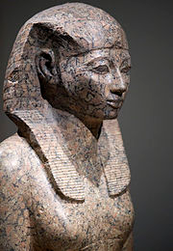

King Tutankhamen
- New Kingdom  - Reigned from 1333 (age nine or ten) to 1323 BC (aged 18).  - Known as the Boy King  - Restored polytheism. (many gods)  - Egypt was very weak during his reign.  - In 1922, Howard Carter discovered Tutankhamen’s nearly intact tomb, in the Valley of the Kings, which received worldwide press coverage. | - His death was accidental. A CT scan taken in 2005 showed that he badly broke his leg shortly before his death, and that the leg had become infected.  - DNA analysis conducted in 2010 showed the presence of malaria in his system.  - It is believed these two conditions (malaria and leiomyomata) combined, led to his death.
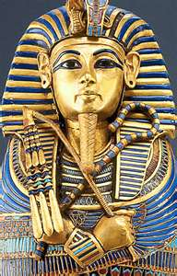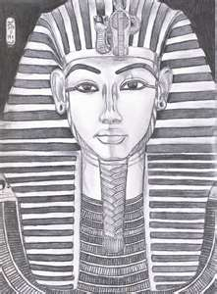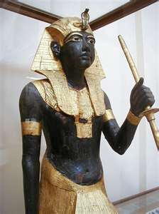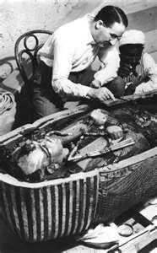
Ramses II
- New Kingdom  - Known as Ramses the Great.  - Lived from c. 1314 BC to 1224 BC.  - Reigned from 1279 BC to 1213 BC.  - Ruled for 66 years, becoming pharaoh at the age of 24 and dying in his 90th year.  - Highly skilled in military conquests. | - He constructed many impressive monuments and temples.  - More statues of him exist than of any other Egyptian pharaoh.  - He is identified as the pharaoh from whom Moses demanded that his people be released from slavery.
